**Journal of Researches in Agricultural Sciences**

**Journal of Researches in Agricultural Sciences Vol. 7**



**©2019 Copyright Faculty of Agricultural Sciences Journal,**

**Ekiti State University, Ado-Ekiti. Nigeria** Vol. 7(1), March 2019 pp -

**Boldness-aggression Syndromes in the zebrafish and the guppies**

**T. O. Ariyomo1, T. Jegede2 and P. J. Watt3**

*1Department of Fisheries and Aquaculture, Federal University, Oye-Ekiti, Ekiti State, Nigeria.*

*2Department Fisheries and Aquaculture Management, Ekiti State University, Ado-Ekiti, Ekiti State, Nigeria.*

*3Department of Animal and Plant Sciences, University of Sheffield, Western Bank, S10 2TN, UK.*

Email: [temitopejegede@yahoo.com](mailto:temitopejegede@yahoo.com)

**Abstract**

Correlations between unrelated personality traits in different contexts often referred to as behavioural syndromes, have been found to exist among individuals. Behavioural syndromes have been documented in a wide variety of taxa and may arise due to correlated behaviours having a similar underlying genetic basis, so that they have become coupled (genetic constraint), or when one hormone acts on several traits (hormonal constraints) or if adaptations to existing selection pressure act simultaneously on multiple traits (adaptive constraints). We examined if there were correlations between boldness and aggression, which would be an indication of a behavioural syndrome in three strains of zebrafish and the guppy. There was some evidence of a boldness and aggression syndrome in only females of two of the zebrafish strains and in the male guppies. Given the limited correlation of these traits within the populations studied, this syndrome was probably due to adaptations to prevailing selection pressures rather than due to genetic constraints.

**Keywords**: behavioural syndromes, zebrafish, guppies, boldness, aggression.

Cite as: T. O. Ariyomo, Jegede, T. and Watt, P.J (2019). Boldness-aggression Syndromes in the zebrafish and the guppies. *Journal of Researches in Agricultural Sciences* 7 (2): x-xx

**Introduction**

Behavioural syndromes occur when consistent but unrelated personality traits, such as boldness and aggression, become correlated across contexts (Bell & Stamps, 2004; Bell, 2005). This means that organisms do not express the traits independently of each other but together, such that, in a bold-aggression syndrome, a bold individual would also be aggressive too, and so it may be impossible for behavioural traits to develop separately (Bell, 2005; Brydges *et al*., 2008). In the rodent *Dipodomys merriami*, Dochtermann & Jenkins (2007) found that boldness and aggression were significantly correlated and bold and aggressive individuals were often less flexible in their responses to changing environmental situations. This inflexibility is consistent with other studies ([Koolhaas *et al*.,](http://www.pubmedcentral.nih.gov/articlerender.fcgi?artid=2288554#bib29) 1997, 1999). The activity–boldness behavioural syndrome in the damselfly, *Lestes congener*, is carried over from the larval stage into the adult, such that, an active larva may survive but an active adult may fall prey to a predator (Brodin, 2009). However, despite being a taxonomically widespread phenomenon (reviewed in Sih *et al*., 2004a, b; Bell, 2007), the mechanisms sustaining the occurrence of these syndromes are unclear.

A number of possible mechanisms have been suggested, which include genetic constraints, where a single gene controls the unrelated traits (Deng *et al*., 1994; Dingemanse *et al*., 2007), hormonal constraints, when the same hormones act on several traits (Koolhaas *et al*., 1999; Veenema *et al*., 2003) and adaptive constraints, or if adaptations to existing selection pressure act simultaneously on multiple traits ([Bell, 2005](http://www.jneurosci.org/content/31/39/13796.long#ref-2); Bell & Sih, 2007). The consequence of behavioural syndromes in a population, apart from being maladaptive in specific context, is that it may constrain the ability of such a population to respond to selection. In this study, we explored the possibility of a boldness-aggression syndrome in three strains of zebrafish and the guppies which are species that are widely used in behavioural and experimental studies.

**Materials and methods**

All the zebraﬁsh strains (London Wild Type (LWT), Tupfel Long fin (TL) and Nacre)) and the guppies used in this study came from laboratory-maintained stock at the University of Sheffield. Prior to behavioural testing which was similar to that described in Ariyomo and Watt (2012, 2013a, b, 2015) and Ariyomo *et al.*, (2013), zebrafish were housed in 10 litre tanks (30 cm x 15 cm x 24 cm) in a recirculatory system kept at 26 ± 1°C, whereas the guppies were placed in aerated tanks (18 cm x 11.5 cm x 11.8 cm) and the water changed daily, under a 12:12 h light/dark photoperiod with a 40 min dusk and dawn period. The ﬁsh were fed twice daily with dry ﬁsh food and brine shrimp.

**Behavioural testing**

Twenty-five males and 25 females of each of the zebrafish strains (LWT, TL and Nacre) and 25 male and 25 female guppies were tested for boldness and aggression. Behavioural testing was similar to that described in Ariyomo and Watt (2012, 2013a, b, 2015) and Ariyomo *et al*., (2013). The open ﬁeld test which has been previously shown to be the most valid measure of boldness (Burns 2008; Ariyomo & Watt, 2012, 2013a &b, 2015; Ariyomo et al., 2013) was used to test for boldness in this study. The number of lines crossed and the degree to which a fish utilized the open field was used as a measure of boldness (Burns 2008; Ariyomo & Watt 2012, 2015; Ariyomo et al., 2013). Fish were placed in a novel tank (48 cm X 26 cm X 22 cm), with the base marked into 24 rectangles (each 8 cm 9 5.5 cm) and ﬁlled with 3 L of dechlorinated water heated to 26°C (Ariyomo *et al*., 2013). Fish that effectively utilized the inner and outer rectangles on the base of the tank and crossed more lines were deemed bold, while the shy ones were those that crossed the fewest lines and did not utilize the inner and outer rectangles on the base of the tank; (Ariyomo *et al*., 2013). Two 18 W daylight ﬂuorescent tubes were placed about 34 cm above the tank to provide light during the experiments. Fish tested for boldness in the open ﬁeld assays were then tested for aggressiveness using the mirror test (Gerlai *et al*. 2000; Moretz *et al*. 2007a, b; Ariyomo and Watt 2012; Ariyomo *et al*., 2013). The number of aggressive interactions made by an individual towards its mirror image was recorded. Fish with the greatest number of aggressive interactions were considered aggressive while those with few aggressive interactions were considered non aggressive.

**Statistical analysis**

The relationship between boldness and aggression in the males and females of the three strains of zebrafish and the guppies was analysed using the non-parametric Spearman’s rank correlation (rho). Statistical analyses were conducted using R statistical software, version 2.12.2 (R Development Core Team 2011).

**Results**

### *Behavioural syndromes in strains of the zebrafish*

There was a positive correlation between boldness and aggression in LWT females (Spearman correlation: rho = 0.52, *p =* 0.008; Fig. 1a) and in TL females (Spearman correlation: rho = 0.50, *p =* 0.017; Fig. 1b), but not for any males or females of the other strains (Table 1).

### 

### *Behavioural syndromes in the guppy*

There was a positive correlation between boldness and aggression in the male guppies (Spearman correlation: rho = 0.50, *p =* 0.012; Fig. 2a) but not for the females (Spearman correlation: rho = 0.14, *p =* 0.504; Fig. 2b

Table 1: Correlation between boldness and aggression in strains of zebrafish

|  |  |  |
| --- | --- | --- |
| Strain/sex | rho value | *p* value |
| Nacre female | 0.13 | 0.525 |
| Nacre male | 0.13 | 0.329 |
| LWT male | 0.03 | 0.877 |
| TL male | 0.19 | 0.372 |

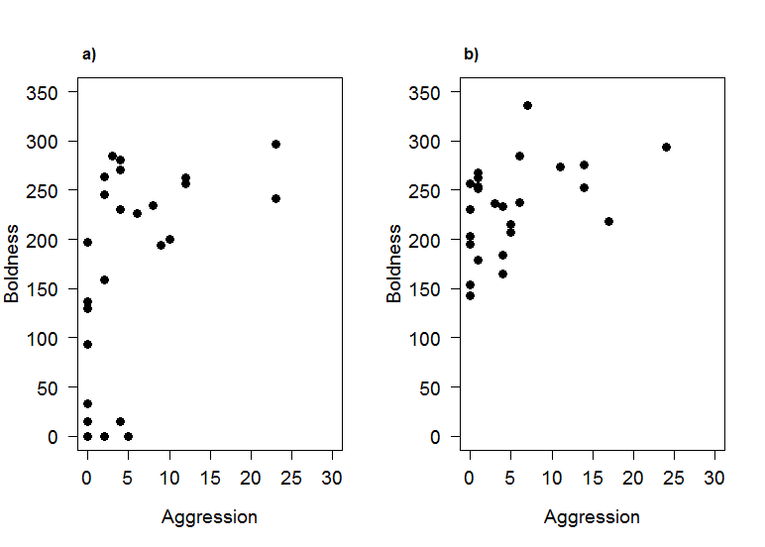Fig. 1: Correlation between boldness and aggression in females of (a) LWT and (b) TL strains of zebrafish.

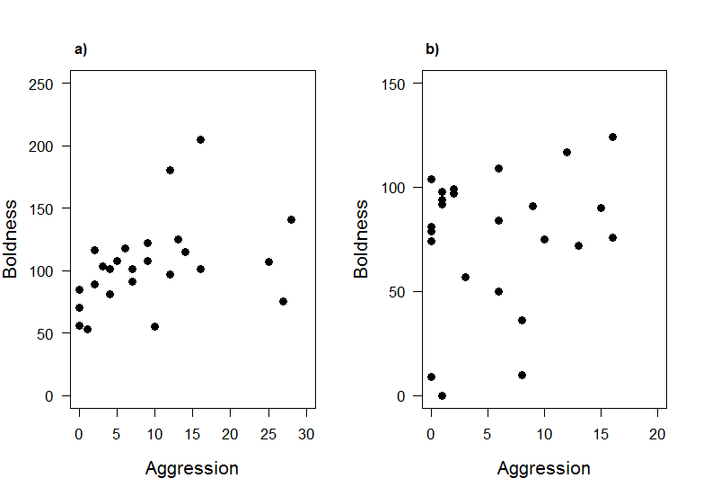

Fig. 2: Correlation between boldness and aggression in (a) the male and (b) the female guppies

**Discussion**

Evidence of a behavioural syndrome in females of two strains was noticed. It has been suggested that behavioural syndromes are more likely to be present in populations with high predation levels rather than in populations with little or no predation, such as in the populations tested in this study (Bell & Stamps, 2004; Bell, 2005; Dingemanse *et al*., 2007, 2010). This is because directional selection by predators might act on multiple traits of a phenotype simultaneously, resulting in a strong correlation between such traits and hence the behavioural syndrome. It may be more advantageous for individuals to show behavioural plasticity across multiple contexts (Sih *et al*., 2004a) because there are costs associated with rigidity, for example, an overly aggressive individual might be aggressive in situations where care is needed, such as towards offspring (Johnson & Sih, 2005) or mates (Wingﬁeld *et al*., 1990).

There was no evidence of a boldness-aggression behavioural syndrome in the female guppies but there was in the males. It is not clear why there were differences between the sexes. The males were more risk prone and curious than the females and so it could be that the behaviours expressed by the males reflected their adaptive responses to what was optimal in the two contexts (Dingemanse *et al*., 2007) hence the strong positive correlation found between both traits. The notion of behavioural syndromes opposes the adaptive hypothesis (Wilson, 1998), which suggests that personality traits are context specific and involve organisms adjusting to the prevailing conditions in their environment (Wilson, 1998). For example, pumpkinseed sunfish, *Lepomis gibbosus,* were consistent with respect to individual variation when exposed to a non-threatening stimulus and also to a predator. However, there was no correlation between these variations across both situations (Coleman & Wilson 1998). Similarly, male Iberian rock lizards, *Lacerta monticola,* that were bold when exposed to high risk predatory attacks, were not particularly bold when faced with low risk predatory attacks (Lopez *et al*., 2005). These studies indicate that organisms show adaptive individual differences to the prevailing selection pressures in their environment in order to maximise fitness (Wilson, 1998; Dingemanse *et al*., 2007). An important ecological implication of behavioural syndromes is that they involve tradeoffs that may reduce behavioural plasticity and they may be maladaptive in specific contexts (Sih *et al*., 2004a, b). Furthermore, correlated traits are forced to evolve together and this may constrain the ability of populations, where behavioural syndromes persist, to respond to selection (Dochtermann & Jenkins, 2007).

Overall, there was some evidence of a boldness and aggression syndrome in females of two of the zebrafish strains and in the male guppies, but, given the limited correlation of these traits within the populations studied, this syndrome was probably due to adaptations to prevailing selection pressures rather than due to genetic constraints (Dingemanse *et al*., 2007).

**References**

Ariyomo, T. O. & Watt, P. J. (2012). The effect of variation in boldness and aggressiveness on the reproductive success of zebrafish. *Animal Behaviour*, 83 (1): 41-46.

Ariyomo, T. O. & Watt, P. J. (2013b). Aggression and sex differences in lateralization in the zebrafish. *Animal Behaviour*, 86, 617–622.

Ariyomo, T. O. & Watt, P. J. (2013a). Disassortative mating for boldness decreases reproductive success in the guppy. *Behavioral Ecology*, 24, 1320–1326.

Ariyomo, T. O. & Watt, P. J. (2015). Effect of hunger level and time of day on boldness and aggression in the zebrafish *Danio rerio*. *Journal of Fish Biology*, 86(6), 1852-1859.

Ariyomo, T. O., Carter, M. & Watt, P. J. (2013). Heritability of boldness and aggressiveness in the zebrafish. *Behaviour Genetics*, 43, 161-167.

Bell, A. M. & Sih, A. (2007). Exposure to predation generates personality in threespined sticklebacks (*Gasterosteus aculeatus*). *Ecology Letter*, 10, 828 – 834.

Bell, A. M. & Stamps, J. A. (2004). Development of behavioural differences between individuals and populations of sticklebacks, *Gasterosteus aculeatus*. *Animal Behaviour*, 64, 1339-1348.

Bell, A. M. (2005). Behavioural differences between individuals and two populations of stickleback (*Gasterosteus aculeatus*). *Journal of Evolutionary Biology*, 18, 464–473.

Bell, A. M. (2007). Future directions in behavioural syndromes research. Proceedings of the Royal Society B, 274, 755-761.

Brodin, T. (2009). Behavioral syndrome over the boundaries of life-carryovers from larvae to adult damselfly. *Behavioral Ecology*, 20, 30–37.

Brydges, N. M., Colegrave, N., Heathcote, R. J. & Braithwaite, V. A. (2008). Habitat stability and predation pressure affect temperament behaviours in populations of three-spined sticklebacks. *Journal of Animal Ecology*, 77, 229–235.

Burns, J. G. (2008). The validity of three tests of temperament in guppies, *Poecilia reticulata*. *Journal of Comparative Psychology*, 122, 344-356.

Coleman, K. & Wilson, D. S. (1998). Shyness and boldness in pumpkinseed sunfish: individual differences are context-specific. *Animal Behaviour*, 56, 927-936.

Deng, C. X., Wynshaw-Boris, A., Shen, M. M., Daugherty, C., Ornitz, D. M. & Leder, P. (1994). Murine FGFR-1 is required for early postimplantation growth and axial organization. *Genes & Development*, 8, 3045–3057.

Dingemanse, N. J., Dochtermann, N. & Wright, J. (2010). A method for exploring the structure of behavioural syndromes to allow formal comparison within and between data sets. *Animal Behaviour*, 79, 439-450.

Dingemanse, N. J., Wright, J., Kazem, A. J. N., Thomas, D. K., Hickling, R. & Dawnay, N. (2007). Behavioural syndromes differ predictably between 12 populations of three-spined stickleback. *Journal of Animal Ecology*, 76, 1128-1138.

Dochtermann, N. A. & Jenkins, S. H. (2007). Behavioural syndromes in Merriam's kangaroo rats (*Dipodomys merriami*): a test of competing hypotheses. Proceedings of the Royal Society B, 274, 2343–2349.

Gerlai, R., Lahav, M., Guo, S. & Rosenthal, A. (2000). Drinks like a fish: zebra fish (*Danio rerio*) as a behaviour genetic model to study alcohol effects. *Pharmacology, Biochemistry & Behavior*, 67, 773-782.

Johnson, J. & Sih, A. (2005). Pre-copulatory sexual cannibalism in ﬁshing spiders (*Dolomedes triton*): a role for behavioral syndromes. *Behavioral Ecology & Sociobiology*, 58, 390–396.

Koolhaas, J. M., de Boer, S. F. & Bohus, B. (1997). Motivational systems or motivational states: behavioural and physiological evidence. *Applied Animal Behaviour Science*, 53,131–143.

Koolhaas, J. M., Korte, S. M., De Boer, S. F., Van Der Vegt, B. J., Van Reenen, C. G., Hopster, H., Hopster, H., De Jong, I. C., Ruis, M. A. W. & Blokhuis, H. J. (1999). Coping styles in animals: current status in behaviour and stress-physiology. *Neuroscience & Biobehavioral Reviews,* 23, 925-935.

Lopez, P., Hawlena, D., Polo, V., Amo, L. & Martin, J. (2005). Sources of individual shy–bold variations in antipredator behaviour of male Iberian rock lizards. *Animal Behaviour*, 69, 1–9.

Moretz, J. A., Martins, E. P. & Robison, B. D. (2007a). Behavioral syndromes and the evolution of correlated behavior in zebrafish. *Behavioral Ecology*, 18, 556–562.

Moretz, J. A., Martins, E. P. & Robison, B. D. (2007b). The effects of early and adult social environment on zebrafish (*Danio rerio*) behavior. *Environmental Biology of Fishes*, 80, 91–101.

R Development Core Team 2011. R: A language and environment for statistical computing. R foundation for statistical computing, Vienna, Austria. ISBN 3-900051-07-0, URL http://www.R-project.org.

Sih, A., Bell, A. & Johnson, J. (2004a). Behavioral syndromes: an ecological and evolutionary overview. *Trends in Ecology & Evolution*, 19, 372–378.

Sih, A., Bell, A., Johnson, J. & Ziemba, R. (2004b). Behavioral syndromes: an integrative overview. *Quarterly Review of Biology*, 79, 241–277.

Veenema, A. H., Meijer, O. C., de Kloet, E. R. & Koolhaas, J. M. (2003). Genetic selection for coping style predicts stressor susceptibility. *Journal of Neuroendocrinology*, 15, 256–267.

Wilson, D. S. (1998). Adaptive Individual differences within single populations. Philosophical Transactions of the Royal Society B, 353, 199-205.

Wingﬁeld, J. C., Hegner, R. E., Dufty, A. M. & Ball, G. F. (1990). The challenge hypothesis – theoretical implications for patterns of testosterone secretion, mating systems, and breeding strategies. *American Naturalist*, 136, 829–846.